INTERNATIONALIZATION & LOCALIZATION IN MGMS:

Localization is a feature by which the MGMS can be adapted to different languages – both regional as well as international. This is done by adding locale-specific configuration and translating the text.

Currently localization is supported only at the system level: - controlling how the MGMS user interface, such as login and common dialogs, adapts to different languages and locales. This mechanism is also used for messages in template scripts.

System
Localization is available currently in Regional languages – Hindi, Malayalam & Tamil
International languages – Italian, French, Spanish, Russian & Chinese

Labels for user interface elements such as dialogs, tabs and buttons are stored in the properties file.

Google Transliteration is used for the conversion. While explaining below, the regional language used is Malayalam.

Malayalam-Unicode Translation

For Malayalam – Unicode translation the Google translator, a Unicode convertor and Dictionaries are used. The links are:

http://www.google.com/transliterate/indic/Malayalam - Google translator
http://rishida.net/tools/conversion/ - Unicode convertor

The files to be translated are in the form:

File name: Var_english.properties
brih_category= Category
brih_FAQ= FAQ

Step 1: Find the meaning of the word with the help of a dictionary.

Step 2: The word meaning is placed in the Google transliterator after selecting the required language. Shown in Fig 1 below.

Figure 1: Google Transliteration Tool
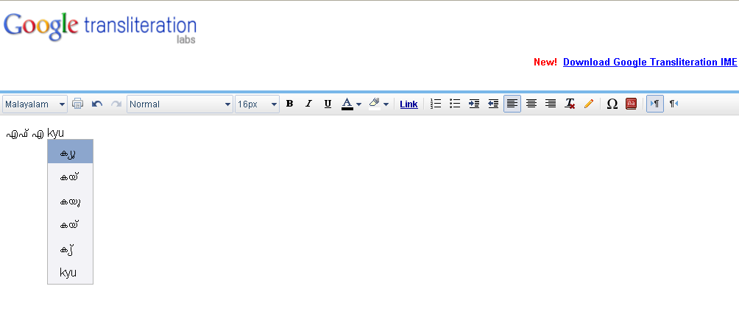

Step 3: The translated word is pasted onto the character column of the Unicode convertor.

Figure 2: Ishida Unicode Converter
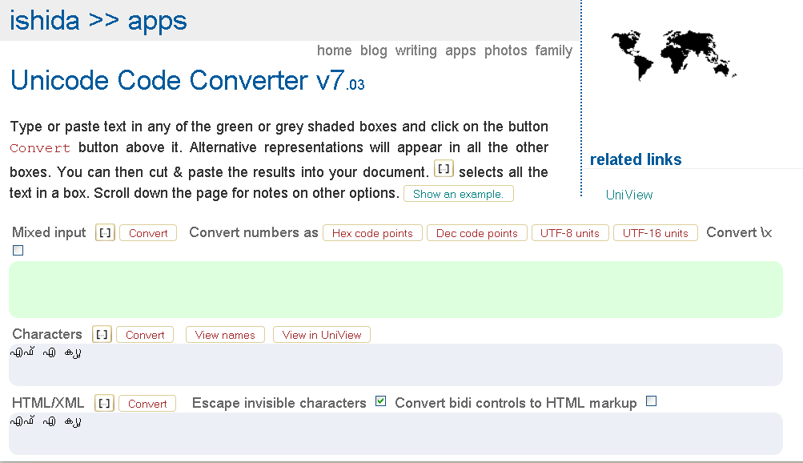

Step 4: Click the button Convert to convert the characters to Unicode. The converted Unicode characters can be seen in JavaScript escapes. (Fig 2 above)

Step 5: The characters are then pasted in the given file. This completes the translation. A sample translated file is shown below.

File name: Var_english.properties
#FAQ(എഫ്എക്യു)
brih_FAQ=\u0D0E\u0D2B\u0D4D\u0D0E \u0D15\u0D4D\u0D2F\u0D41
# Category(തരം)
brih_cat= \u0D24\u0D30\u0D02

Currently the MGMS does not redirect visitors to the localized URL automatically. The behavior is configured on the web server by allowing the visitor to select a language from a dropdown on the log in page, then redirect them to the correct URL.

Possible future scope

Content. Handles the storing and serving of localized content in the JCR.
Authoring. Adapts the authoring interface to support localized content entry. The default implementation adds a language dropdown in the mainBar and displays a two-letter language identifier (en, ge, fr etc.) next to field labels in the content entry dialog.

One of the languages is always a fallback language. If no target language content is found, the system displays content in the fallback language instead.

- Detect the visitor's origin from their IP or the referring page, then redirect them to the localized site automatically.
- Detect the visitor's preferred locale from their browser settings, then redirect them to the localized site automatically.

